NEW! - DNA Testing for CEA Arrangements
ISDS / Animal DNA Diagnostics Ltd / OptiGen
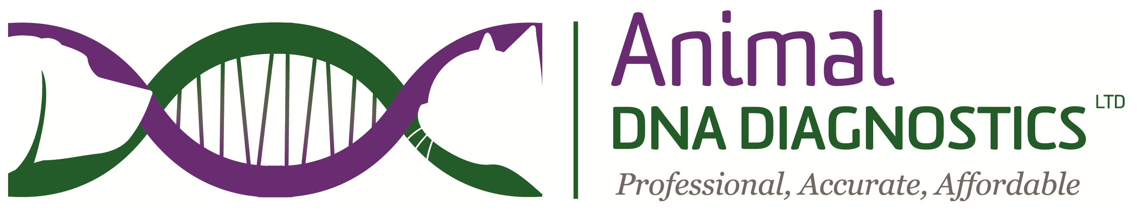
The Society is pleased to announce an additional process for members to obtain DNA testing for CEA. Arrangements have been made with a laboratory in Cambridge (Animal DNA Diagnostics Ltd) to extract DNA from blood samples and send them direct to OptiGen. This process removes the difficulties experienced with the Royal Mail and sending blood through the post overseas, which then allows members to continue to use the Society discount with OptiGen.
OptiGen have agreed to cover the costs of the DNA extraction, therefore Animal DNA Diagnostics Ltd will charge members only £10 (including VAT) to cover storing half of the DNA sample, archiving the remaining blood sample, admin and postal charges. Please note this £10 fee covers either multiple samples sent together or just one sample.
It is recommended that half of the DNA sample is stored by the laboratory to cover occasional loss in the post, damaged samples and should analysis of DNA be required for any other reason. The archived blood can also be tested for other issues.
To use this process:
- Access the online OptiGen form – complete the form http://www.optigen.com/opt11_form.taf?lang=en and enter your credit/debit card details for payment.
- This will give you an immediate 25% discount (ISDS discount code for 2014 is ISDSX4)
- Print off the form and take it with you to the vet together with your dog
- The vet should check that the dog presented is the dog on the form (by reading the microchip) before taking the blood sample
- A 1ml blood sample is sufficient, and this should be an EDTA sample
- The owner and the vet date and sign the form; the vet takes a photocopy of the form for the owner.
- The vet practice packages the bloods as appropriate and includes the printed online test form. Post to Animal DNA Diagnostics Ltd, William James House, Cowley Road, Cambridge, Cambridgeshire, CB4 0WX along with a cheque for £10 made payable to Animal DNA Diagnostics Ltd, or direct bank transfer to Sort Code: 40-34-38 Account Number 91444719, quoting your name as the reference.
Animal DNA Diagnostics Ltd will confirm by email to the owner when samples are received and then shipped to Optigen. OptiGen will email the test results direct to the owner, and then on to the Society on a quarterly basis.
The costs to members using this system will be around £83.00 for the OptiGen fee (dependent upon currency exchange rates), £10 Laboratory fee plus the vet fee for the blood draw.

Animal DNA Diagnostics Ltd also offers Society members a DNA profiling and parentage verification service. The fee is £25 + VAT; anyone submitting 10 or more samples together would get an additional 10% off, and 20 or more 20% off. Orders can be placed online at www.animaldnadiagnostics.co.uk. For further information about this service please visit the website or contact June - Tel: 01223 395577 or 07870 456808 or email info@animaldnadiagnostics.co.uk

